FALLBACK

Game Design Document
(version 2)

Uncertain Studios

Producer Tige Saltz

Designer Shane Beck

Product Manager Jonah Hoskins

Technical Director Kevin Wallace

Programmer Jackson Clouse

GAM 450 – Spring Semester 2003

Table of Contents
Idea 4
Summary 4
Key Features 4
Platform 4
Target Market 4
Background 5
Back story 5
Story 5
Game Play 6
Single player 6
Mission Objectives 6
Multiplayer 6
Game Flow 7
Input Design 7
Player Design 7
Player Description 7
Player AI 8
Inventory 8
Weapons 8
Equipment 8
Vehicles 8
Salvaging 9
Enemy Design 9
Enemy Description 9
Enemy Units 9
Enemy AI 10
Level Design 10
User Interface 11
User Flow 11
Menu System 11
Start Menu 11
In-Game Menus 12
HUD 13
Game Screen 14
Art, Sound 14
Art Requirements 14
Art List 14
Sound Requirements 17
Sound List 17
Music 18
Technology 18
Technical Analysis 18
Experimental Features 18
Major Development Tasks 19
Technical Requirements 20
Naming/Coding Conventions 20
Version Control 20
Tools 20
Engines 20
Game 20
Graphics 20
Sound 20
Input 20
Menu 20
Networking 21
Installer 21
Marketing 21
Genre 21
Competitors and Price Comparison 21
Team Information 22
Shane Beck, Designer 22
Jackson Clouse, Programmer 22
Jonah Hoskins, Product Manager 22
Tige Saltz, Producer 23
Kevin Wallace, Technical Director 23
GDD Version 2 Changes 24

Idea
Fallback is a top-down, squad based real time strategy game (RTS) in which the player controls a small group of soldiers fighting an alien force.

Summary
Fallback is a squad-based RTS game set on an alien planet in the near future. The player will control a group of human soldiers stranded at a remote outpost, trying to get back to the space-launch pad to escape the planet. Each soldier has different skills, and the player can equip each soldier as he or she sees fit. The soldiers have limited equipment, ammunition, and manpower, requiring the player to find other human outposts with additional supplies and other troops to command. The player will also find abandoned vehicles and buildings that can be used to aid their escape.

Key Features
- Command a squad of unique individuals with different skills; not just a collection of multiple identical units. Each person has varying skills and abilities. Though they may be specialized in one area, there’s no reason an engineer can’t try his hand with a sniper rifle.

- Equip your squad as you see fit. Weapons, armor, and specialized equipment can be found and distributed among your troops. Rocket launchers, heavy machine guns, and sniper rifles will help you eliminate your enemies. Armor, field medic kits, and computer-assisted targeting systems will keep them from doing the same to you.

- Use the newest and best vehicles to further demolish your foes. Speedy jeeps and lumbering tanks carry heavy artillery and heavy armor, making them a force to be reckoned with on the battlefield. Plus, superior ergonomics and ease of use keep their drivers in complete comfort while dealing out massive amounts of devastation.

Platform
P4 1.6 GHz
128MB Ram
Windows 2000/XP
DirectX 8.1
Keyboard
Mouse

Target Market
Fallback will target the Teen and Older male computer gamer demographic.

Background

Back story
In the not-too-distant, but at the same time not-very-close future, humanity is expanding through space. Near-light speed travel is becoming more and more efficient, and top minds are still at work improving the understanding of light speed. A separate branch of research, though, stumbled across a breakthrough that allows matter to travel at speeds much faster than light, crossing entire galaxies in only moments. The technology is still under development (and kept under wraps) and is not available to the public, but already some major world governments are expanding into unimagined depths of space. The military command of the Continental Earth Government (CEG) has set up outposts on several planets, establishing way stations to re-supply and refuel ships on their way to explore further into deep space.

Though outposts are built on any available planet, preference is given to those with human-survivable climates, thus avoiding the costs of building an atmospherically sealed, geologically stable environment, with similarly human-safe resource harvesting and exploration equipment. Way stations consist of an orbital station which is maintained by a ground-based outpost. Ships dock at the orbital station while the planet side crews harvest resources and transport them to the station via a surface-to-orbit launch pad.

Story
Fallback takes place on one of these outpost worlds: Othala, a planet several steps down the trail from Central Command. Othala’s climate is survivable, though a little cold. The air contains a sufficient amount of oxygen, a decent amount of nitrogen, and nothing overly dangerous. The grass is green, the sky is blue (through half of the planet’s orbit, anyway), and the water is clean H2O, with a little bit of Nb and Zr (nothing a little filtration can’t clean out).

The ground presence on Othala has expanded rapidly after the discovery of large deposits of valuable minerals near the planet’s surface. A network of outposts spread out from the primary post, with a steady stream of convoys transporting resources from the outer mines to the shuttle launch pads. Progress has been steady and uneventful, and new mineral sites are located frequently. But things change, as they are wont to do…

Without warning, an army of unidentified alien creatures have appeared and decimated most of the Othala outposts. Central Command has issued orders for all planet side personnel to fall back to the space launch pads and evacuate the planet. With mostly unarmed convoys traversing a decimated road system, the evacuation is facing extreme difficulties. Many troops have fortified outposts and are fending off the alien wave, while others are pinned down and unable to escape. The CEG has sent many high-level military officers to the Othala orbital station, where they can begin to organize the remaining personnel and orchestrate a plan to finish the evacuation.

Game Play

Single player
The story of the single player campaign will take the user through several sequential missions. The goal is to guide the remaining crews of the Othala outposts to the central launch station where they will be able to escape the planet. Over the course of the game, the player will control many separate groups of personnel. Sometimes the same group will go through multiple missions, other times the player will only see a unit once.

Mission Objectives
In multiplayer mode, players can choose to play through the single player missions cooperatively, or control separate human forces and compete to complete objectives on dedicated multiplayer maps. Each multiplayer map will have its own objectives, usually falling into the categories of Last Man Standing, Capture The Objective, and Defend The Base.

Multiplayer
In multiplayer mode, players can choose to play through the single player missions cooperatively, or control separate human forces and compete to complete objectives on dedicated multiplayer maps. Each multiplayer map will have its own objectives, usually falling into the categories of Last Man Standing, Capture The Objective, and Defend The Base.

- Last Man Standing: Each player will be given a starting force. The player who has the last surviving force wins.

- Capture The Objective: The map will have one central objective. Players will attempt to complete the objective first.

- Defend The Base: The players will be put on two teams. One team will start within a defensive area, and the other team will attempt to attack and destroy this area.

Game Flow
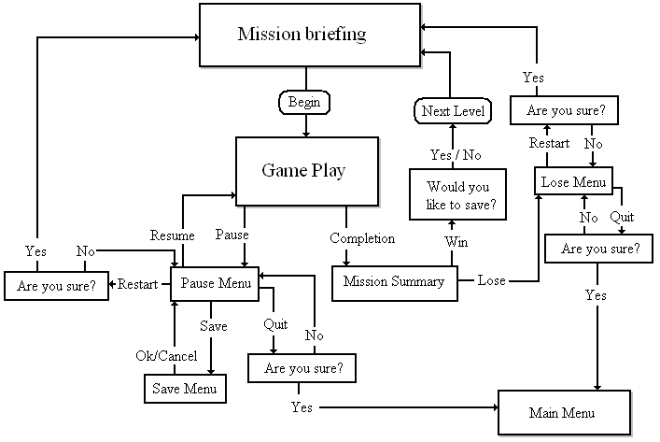

Input Design
Fallback will utilize the mouse and keyboard for input. The player will use the mouse to select units and direct them to move. Buttons for all commands are in the lower right of the screen and can be accessed with either the mouse or keyboard shortcuts. Multiple units can be selected, and command functionality remains the same. Certain commands are restricted to specific units.

Player Design

Player Description
The player is in the role of an overseer of the Othala outposts. When the alien threat appears, the order is given for all station personnel to fall back to the main landing zone, where the surface-to-orbit shuttles can be used to evacuate the planet. From a command post either in orbit over Othala or directly from Earth, Overseers have access to several geo-synchronous “spy” satellites through which they can view the planet’s surface. Using each individual soldier’s computer uplink, the overseer can give commands, which appear on the soldier’s HUD to denote waypoints or instructions.

Player AI
Human AI will be limited to reloading and sighting of enemies in passive mode, and attacking sighted enemies (but not pursuing) in aggressive mode. The player will be responsible for ordering units to move, take cover, or use special skills.

Inventory

Weapons
Weapon | Magazine Size | Rate of Fire (rounds/minute) | Damage | Accuracy
Assault Rifle | 40 | 1200 | 30 | Mid
Support Rifle | 200 | 650 | 35 | Low
Sniper Rifle | 6 | 15 | 750 | High
Shotgun | 14 | 60 | 25 * 10 | High
Handgun | 24 | 200 | 20 | Mid
RPG | 1 | 6 | 5000 | High
Grenade | 1 | 20 | 2000 | Low

Vehicle Weapon | Rate of Fire | Damage | Accuracy
VMWS | 800 | 120 | Mid
Tank Cannon | 20 | 25000 | High

Equipment
- Armor: Light, Medium, and Heavy armor increases a unit’s durability.

- Computer Assisted Targeting headset: Increases unit’s ability to spot enemies.

- Field Medic Kit: Allows for rapid healing of wounded personnel.

- Stimulant Pack: Increases a unit’s fighting ability for a short time.

Vehicles
- Jeep: A light vehicle, intended for reconnaissance missions. Being a military model, it comes equipped with a standard Vehicle Mounted Weapons System (VMWS). The Jeep can carry a driver, a gunner, and two passengers and is lightly armored. As a scouting vehicle, it can easily travel over most rough terrain and is least affected by the damaged roadways.

- APC: The resource convoys consist mainly of APCs converted to carry heavy cargo. APCs are the best option for moving the remaining troops through hostile areas. They can hold a driver, a gunner, and eight passengers. The APC carries two machine gun turrets, and has heavy armor. Though the APC is a treaded vehicle, it performs best on roads and other flat terrain.

- Tank: In the early phases of expansion, the Othala outposts were constructed as hostile-area outposts. As such, some have stocks of weaponry and armor, and combat-ready vehicles. A small number of tanks were dropped to the surface, but have only been used to clear foliage until now. The tank’s armament consists of two VMWSs and a 120mm main gun, and is crewed by a driver and two gunners. The tank’s armor is extreme, and should be able to handle anything the Othala natives can throw at it.

Salvaging
During the course of the game, vehicles, weapons, and equipment will become damaged. A soldier, using his Tech skill, can Scrap these damaged items. The amount of scrap gained from an item is relative to the soldier’s tech skill. This scrap can be used to repair other items of a similar type (i.e. Vehicle scrap is used to repair vehicles, armor scrap is used to repair armor). Scrap is stored in a unit’s inventory, and can be transferred to other units or stored in an armory.

Enemy Design

Enemy Description
The player is facing off against the previously unseen natives of Othala. The alien force appeared suddenly and caught the human outposts off-guard. With the element of surprise and superior numbers, the aliens were able to inflict extreme damage to the human force. The aliens initially attack with their native weaponry, including odd mechanisms and comparatively primitive weapons. However, in later missions the aliens will begin to use captured human weaponry and equipment.

Enemy Units

Alien Dog
Not completely accurate, but it describes their role in the alien army. These creatures are somewhat intelligent, but their battle strategy usually consists of attacking en masse with their natural weaponry of claws (?) and teeth.

Alien Soldier
This alien performs the same function as a standard human soldier. What this means is, the Alien Soldier is a versatile and dangerous enemy. They typically use a not-yet-understood weapon that uses pressurization of some type to fire a corrosive, crystalline liquid substance at high velocities. With a bit of research, these aliens may eventually find out how to use human weaponry and vehicles.

Alien Brute
This is a big alien. They appear to be as intelligent as the alien dogs, but much, much bigger. Their physiology appears to be somewhat like the Alien Soldiers’. This doesn’t mean much, but at least they fall over when shot enough times.

Alien Pack Beast
This beat by itself isn’t dangerous at all. However, the alien soldiers use these creatures to carry a form of heavy artillery, which is quite dangerous.

Enemy AI
- Alien Dog – Run forward and much.
- Alien Soldier – Shoot and go for cover.
- Alien Brute – Move forward and attack first enemy in range.
- Alien Pack Beast – Fire at enemy.
- Alien Soldier with Pack Beast – Follow around beast, looking for enemy. When enemy is seen, alerts beast where to fire.
- Infested Jeep – Drive around and when you see an enemy shoot it.
- Infested Tank – Shoot big gun at enemy.

Level Design
Levels will be created to reflect the undeveloped forest terrain, which covers most of Othala’s surface. Trees and rivers will comprise most of the terrain features, with human-built roads and buildings speckling the landscape.

Buildings
Othala outposts are built with only a few distinct types of buildings. Each building has a function, and can also be used to shelter troops.

Command Post
The Command Post is where all the important functions are handled. Personnel live in this building, the communications equipment is here, and this is where most of the survivors are hiding. This building will usually be the target for completing objectives. They are large, sturdy, and can shelter any number of troops. Building Health: 80,000

Armory
Armories are storage buildings. Since Othala was all quiet before the attack, they are usually lightly stocked. This is where you will find most of the weapons and equipment during the course of the game. This building is heavily armored, and can hold 12 troops safely inside. Building Health: 50,000

Bunkers and Scout Towers
Bunkers and Scout Towers are meant to give troops cover while allowing them to fire on enemies. They are light when compared to other buildings, but can withstand much enemy fire. Bunkers can hold 5 troops, while scout towers can hold 3. Building HP: 20,000 (Bunker), 10,000 (Tower)

Other
The outposts also feature chain link fences and sandbag walls. The fences hinder movement but not fire, and the sandbags provide cover. These cannot be destroyed.

User Interface

User Flow
- Start menu
- To game
- In game
  - GUI
  - Inventory menu
  - Game Menu
4. End game

Menu System

Start Menu
- Single Player
  - New Game: Start New Game? Y/N. Begins new game, or goes back to Main Menu.
  - Load Game: Brings up list of saved games. Load Game and Delete functions.

- Multiplayer
  - Host: Goes to multiplayer lobby. Host can select game type and map. When all players are ready, the host can start the game.
    - Co-op
    - Vs.
  - Join: Displays a list of all games found. Joining game takes user to multiplayer lobby. Player can chat, and set Ready state (Y/N).
  - Player Setup
    - Name

- Options
  - Sound Volume
  - Music Volume
  - Resolution

- Credits

- Exit
  - Yes
  - No
  - Taunt

In-Game Menus
- Inventory
  - Item Grid
  - Detailed, numeric unit stats
  - Detail text for item description

- Map
  - Terrain View
  - Mission Description
  - Mission Objectives
  - Unit/Structure List

- Game Menu
  - Load Game
  - Restart Mission
  - Options
  - Exit Game

- Building Inventory Menu
Swapping inventory from one unit to a building or vehicle uses a special interface. When the player selects a troop and a building or vehicle, a menu will appear with both the units’ inventory. The player can drag items back and forth between them, though a troop cannot be given more items than he can carry.

HUD
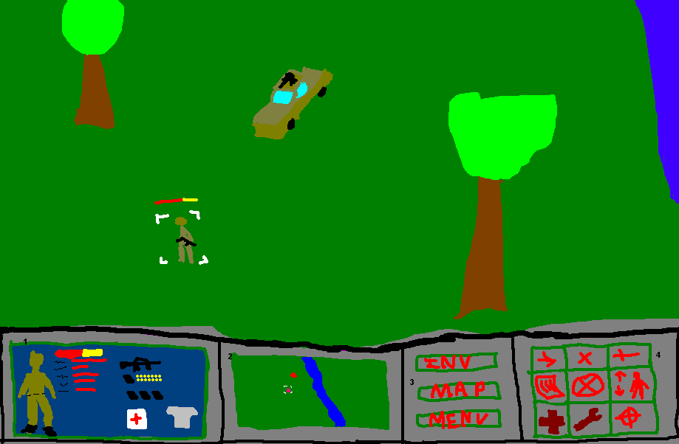

- Selected-Unit details
  - Unit portrait
  - Health Bar
  - Summarized stats
  - Relevant Inventory

- Mini Map
  - Terrain
  - Visible Units
  - Selected Units highlight

- Menu access
  - Inventory
  - Map
  - Game Menu

- Unit Commands
  - Move
  - Stop
  - Attack
  - Reload
  - Hold Position
  - Stand/Prone
  - (Medic) Heal
  - (Tech) Salvage
  - Passive/Aggressive AI

Game Screen
- Interface
  - Left click
    - On friendly unit, vehicle, or building: select object.
    - On terrain: De-select all.
    - On enemy unit: Display information.
  - Right click
    - With nothing selected: Nothing
    - With unit selected
      - On ground: Move
      - On enemy: Attack
      - On vehicle: Enter Vehicle
      - On building: Enter building
    - With Vehicle/Building Selected
      - On selected vehicle/building: Unload Vehicle/Building

  - Keyboard Shortcuts
    - A: Attack
    - S: Stop
    - R: Reload
    - X: Hold Position
    - M: Move
    - D: Prone/Stand
    - T: Aggressive/Passive AI
    - B: (Engineer) Salvage
    - H: (Medic) Heal
    - U: Unload Vehicle

Art, Sound

Art Requirements
Format: Bitmap/3DS->.x
Style: Realistic future

Art List
- Terrain
  - Grass
  - Water
  - Border Grass/Water
  - Bridge
  - Trees
  - Sandbag wall
  - Chain-link fence
- Vehicles
  - Models
    - Jeep
    - APC
    - Tank
  - Textures
    - Regular texture (for each vehicle)
    - Damaged texture (for each vehicle)
  - Accessories
    - Tank main turret
    - Machine gun turrets

- Buildings
  - Models
    - Command Center
    - Armory
    - Vehicle bay
    - Cement Bunker
    - Scout Tower
    - Stationary Gun Turret
  - Textures
    - Regular texture (for each building)
    - Damaged texture (for each building)

- Human Units
  - Troops
    - Generic Human model
      - Medic skin
      - Technician skin
      - Soldier skin
  - Troop Animations
    - Generic Human Model animations
      - Move
      - Firing
      - Throw Grenade
      - Death
      - Prone Move
      - Prone Firing (each weapon)
      - Prone Throw Grenade
      - Prone Death

- Alien Units
  - Alien Troops
    - Alien Dog
    - Alien Soldier
    - Alien Pack Beast
    - Alien Brute
  - Alien Animations
    - Idle
    - Move
    - Melee Attack
    - Death
    - Alien Soldier Specific
      - Fire Rifle

- Inventory Items (2d art)
  - Weapons
    - Assault Rifle
    - Light Machine Gun
    - Shotgun
    - Handgun
    - Rocket Launcher
    - Grenade
  - Armor
    - Light
    - Medium
  - Equipment
    - Field Medic Kit
    - Stimpack
    - Computer Assisted Target system

- GUI
  - Cursor
    - Menu cursor (arrow)
    - Action cursor (crosshair)
      - On
      - Off
  - Heads Up Display
    - Command Buttons
      - Inventory
      - Map
      - Menu
    - Action Buttons
      - Movement
      - Stop
      - Attack
      - Reload
      - Hold Position
      - Stand/Prone Toggle
      - Medic
      - Salvage
      - Aggressive/Passive Toggle
  - Inventory Window
    - Background tile
  - Map Window
    - Background image
    - Map for each level
    - Check boxes
      - Checked
      - Unchecked
  - Menu Window
    - Save button
    - Restart button
    - Exit button
  - Out-of-game Menu and buttons
    - Background image
    - Button image (text overlay)
    - Ammo
    - Selection box (3d model)
    - Life bar (3d model)
    - Sighted mark

Sound Requirements
Format: Wave
Style: Realistic Future

Sound List
- Human unit sounds and voices
  - Selected
  - Acknowledgement
  - Pain
  - Death
  - Firing
    - Handgun
    - Shotgun
    - Support rifle
    - Sniper rifle
    - Assault rifle
    - Rocket launcher
  - Reload
    - Handgun, Assault, and Support
    - Rocket launcher
    - Shotgun
  - Grenade thrown
  - Grenade explode
  - Medicate
  - Salvage

- Vehicle sounds
  - Movement acknowledgement
  - Firing machine gun
  - Firing tank über-cannon
  - Hit
  - Destruction

- Alien unit sounds and voices
  - Sight
  - Pain
  - Attacking
  - Range Attack
  - Death

- Building sounds
  - Selected
  - Destruction

- Ambient sounds
  - Nature sound (looped)

- UI sounds
  - On click
  - On highlight

Music
Format: MP3
Style: Background and ignorable

Technology

Technical Analysis

Experimental Features
Nothing we plan on doing in this game, engine-wise, is new technology. However, we have not tackled several of the issues that we plan on handling, including:
- Models attaching to other models (i.e. Weapons attached to troops)
- Animation with models
- Fog of war: limited visibility of units based on other units.

Major Development Tasks
- Graphics engine
  - Initialization of Direct3D
  - Drawing models
  - Drawing sprites
  - Drawing text
  - Texturing models
  - Animation
- Sound engine
  - Initialization of DirectSound
  - Multithreading
  - Playing sounds
- Game engine
  - Data structures
  - Object interaction
- Input engine
  - Initialization of DirectInput
  - Retrieving Input
- AI
  - Path finding
  - Decision-making
- Mapping
  - Loading and displaying
- File input/output library
  - Reading maps
  - Reading objects
  - Reading models
  - Reading levels
  - Saving and loading games
- Networking engine
  - Initialization of DirectPlay
  - Menu infrastructure
  - Game engine connection
  - Communication
- Menu library
- Other libraries (math, windows, animation, etc)

Technical Requirements

Naming/Coding Conventions
We will have conventions for naming files, variables, and functions, as well as conventions for commenting. They will be decided in time for the Technical Design Document, but require a bit more thought and discussion than we have as of yet been able to give them.

Version Control
We will be utilizing Microsoft Visual SourceSafe to automate our version control and code sharing.

Tools
For modeling and animation, we plan on using 3DS Max and an export tool to save in Direct3D X file format.
Maps and other in-game data will be stored in plain text format, and will be edited appropriately using Notepad or some other low-level text-editing program.

Engines

Game
The game engine will encompass all of the following engines, and bring them together to deliver the product. It will also handle AI and physics routines.

Graphics
The graphics engine will utilize Direct3D and DirectX technologies to render text, 2D images, and 3D models on screen.

Sound
Utilizing DirectSound, the sound engine will be responsible for the playing of music clips and sound effects. The sound engine will be multi-threaded, so as to provide as seamless an audio experience as possible.

Input
The input engine will handle mouse and keyboard input, and relay these upon request to the game engine. It will be built utilizing DirectInput.

Menu
All menus will be handled in game by the menu engine. It will interface very closely with the game engine, and will encompass the in-game inventory.

Networking
The networking engine will be built using DirectPlay, and will utilize the peer-to-peer APIs.

Installer
We will be using a freeware software application called Inno Setup (http://www.jrsoftware.org/isinfo.php) for the creation of our installation program.

Marketing

Genre
Fallback falls into the category of 3D overhead squad-based Real Time Strategy.

Competitors and Price Comparison
- Fallback – $39.95 – Uncertain Studios
- Command and Conquer: Generals – Not out – Westwood Studios
- Fallout Tactics – $19.95 – Interplay
- Warcraft 3 – $59.95 – Blizzard

Team Information
Uncertain Studios is made up of five people (Shane Beck, Jackson Clouse, Jonah Hoskins, Tige Saltz, and Kevin Wallace), each of whom has had experience on a minimum of three different projects over the course of their DigiPen careers.

Shane Beck, Designer

PROJECT HISTORY
WordSmith - Text Adventure – worked as the designer and a programmer, did general coding, puzzle design, wrote the game design document

Squadron Blackops - 2D side scroller – worked as the technical writer and programmer, did AI, physics

Bump-A-Rama - top down 3D bumper car adventure – worked as designer and a programmer, did game design, level design, physics, game items, sound, wrote the game design document

Jackson Clouse, Programmer

PROJECT HISTORY
Black Horizon – worked as a programmer, programmed a pong mini-game, the game menus, and also attempted to get some of the windows functions working.

The Ticket Home – 2D side scroller – worked as a programmer, did the item spawning, enemy spawning for the Arena level, and statistic displaying.

Jailbreak – 3D FPS – worked as a programmer, did the networking, implemented a Server/Client model using Direct Play.

Jonah Hoskins, Product Manager

PROJECT HISTORY
Rules of Engagement – Text adventure – worked as a programmer, did content and input, coded the mechanism to take words and turn them into an amusing story, dubbed Madlibs.

Squadron Black Ops – 2d Side Scroller – worked as a programmer and tech writer, did AI for enemy planes, worked in tandem with the lead programmer building the graphics engine.

Bump-A-Rama - Top down 3d bumper car adventure – worked as producer and a programmer, did AI for enemy cars, game design, physics engine, sound.

Tige Saltz, Producer

PROJECT HISTORY
Blockhead – Puzzle game - Producer, also worked as a Programmer, did the cheats and level testing for the game, did object collision.

Intergalactic – Space Shooter - Programmer, did the pixel-based collision detection, the algorithm for the homing missiles, and did the enemy AI.

The 8th Amulet – Graphic Adventure/RPG - Product Manager, also worked as a Programmer for the 1st half of the project, Technical Director for the second half of the project, wrote the sentence parsing engine, wrote the battle engine, wrote all of the in-game description/action text for items and events in the game, did the sentence parsing database, wrote one of the boss monsters’ AI, wrote the inventory system, tested the game for bugs, wrote the Technical Design Document for the second half of the project, created some of the in-game art for the inventory system.

AV Assault – AI/Strategy based mech combat game - Producer, also worked as a Programmer, wrote the items database, created several AI routines for the mechs within the game, did the art for the items in the game, testing the game for bugs, created the in-game icon art for the build AV and build AI menus.

Kevin Wallace, Technical Director

PROJECT HISTORY
Rules of Engagement – Text Adventure with a negotiating twist – Programmer and Product Manager. Did level design, general programming.

Gravedigger – Graphical Action game where you hit zombies and rebury them - worked as Programmer and Art Director, did art, scripting, and general programming.

Valence – 3d Puzzle game of building stuff - worked as a programmer and lead tester, did level design, and sound system programming.

GDD Version 2 Changes

- Fixed header, added Class / Date information.
- Slight update to Player AI section.
- Added numeric damage for weapons in Inventory section.
- Added section for Vehicle Weapons in Inventory section.
- Removed "Mechanics Bay" building type.
- Added specific buildings' Health.
- Changed In-Game Menu specification for swapping inventory between units and vehicles/buildings.
- Updated HUD picture, added "Passive/Aggressive AI" button.
- Art List:
  - Removed Infested texture requirements.
  - Removed Backpack inventory item
  - Removed Heavy armor type

