FALLBACK

Technical Design Document
(version 2)

Uncertain Studios

Producer Tige Saltz

Designer Shane Beck

Product Manager Jonah Hoskins

Technical Director Kevin Wallace

Programmer Jackson Clouse

GAM 450 – Spring Semester 2003
Table of Contents
Introduction 4
Platform and OS 5
Target Platform 5
Development Platform 5
External Code 5
Control Loop 5
Modules 6
Game Module 6
Overview 6
Classes/Structures 6
Public Interface 6
Private Interface 6
Graphics Module 6
Overview 6
Classes/Structures 6
Public Interface 7
Private Interface 7
Sound Module 7
Overview 7
Classes/Structures 7
Public Interface 7
Private Interface 7
AI Module 8
Overview 8
AI States 8
Classes/Structures 8
Public Interface 9
Private Interface 9
Networking Module 10
Input Module 10
Overview 10
Classes/Structures 10
Public Interface 10
Private Interface 11
File I/O Module 11
Overview 11
Classes/Structures 12
Public Interface 13
Time Module 13
Overview 13
Classes/Structures 13
Public Interface 13
Private Interface 13
Math/Physics Module 13
Overview 13
Classes/Structures 13
Public Interface 14
Windows Module 14
Overview 14
Public Interface 14
Menu Module 14
Overview 14
Classes/Structures 15
Public Interface 16
Private Interface 16
Data Flow 16
Game Physics and Statistics 16
Optimization 17
Multiplayer/Networking 17
Peer-To-Peer Structure 17
Updating Data 17
AI Opponents 17
Data Structures 17
Public Functions 18
Private Functions 18
DirectPlay Message Handler 19
External Libraries 19
Packets 19
UI 21
In-game mouse interface 21
Keyboard interface 21
HUD 22
Installer 23
Copy protection / Anti-hacking devices 23
Tools 23
Appendix A: Naming/Coding Conventions 24
Files 24
Functions 24
Variables 24
Commenting 24
Appendix B: Graphics/Sound Formats 25
Graphics Formats 25
Sound Formats 25
Appendix C: Script File Format 25
TDD Version 2 Changes 26

Introduction
Fallback is a top down 3D Real-Time Strategy game. The player controls small groups of human soldiers trapped on the outpost planet Othala, fighting through an alien force in order to escape. Rather than giving the player resources and allowing them to build endless streams of identical units, each mission in Fallback will provide the player with a small number of soldiers and some equipment. Any soldier can use anything, or do anything, but each unit has varying attributes and skills that make them better suited to certain equipment or tasks. Units’ skills are represented numerically, describing each individual’s strength, perception, firearms and demolitions skill, and knowledge of engineering and field medicine.

Players will not be able to build more units during the game, but often the player will be required to rescue or assist other soldiers, putting them under the player’s control. There are also weapon caches and other sources of equipment to re-supply the player throughout the missions. Using a unit’s engineering skill, damaged equipment and vehicles can be salvaged for usable parts, which can be used to repair other objects of the same type. For vehicles, this will require access to a mechanics bay. For weapons and armor, these operations can be performed in the field.

Besides units and vehicles, the outposts of Othala contain many types of buildings the player can use. Outposts are built with a defensive perimeter surrounding a central Command Station and utility buildings. Command Stations will be the target of many mission objectives, and can also function as a defensive structure when manned by armed troops. Weapons and armor are stored in Armories, and Mechanics Bays allow vehicle maintenance. Perimeters are secured by fences, watchtowers, and hardened bunkers, which give troops a fortified position from which they can deal damage in relative safety.
Rounding out the player’s arsenal are vehicles, including a lightweight scout vehicle, a heavily armored personnel carrier, and the monolithic tank. With a pilot and a gunner, vehicles are potent forces on the battlefield. These powerful units are rare, but even a single scout vehicle can turn the tide of a confrontation.

With such an impressive array of power at the player’s command, the alien force must be appropriately fearsome. Mostly, this is accomplished the old-fashioned way: lots and lots of aliens. There are several types of alien facing off against the human fighters. Swarms of dog-like creatures attack in large groups. Bulky, armored foes absorb huge amounts of firepower. Versatile alien soldiers use many of the same tactics as the human forces. Later missions may even have the player coming head to head against aliens using captured human weaponry. There may also be other tricks levied against the player, making the process of escaping Othala a long, intensive struggle.

Platform and OS

Target Platform
Pentium 4 1.6 GHz
128 MB RAM
Keyboard and Mouse
Windows 2000/XP
32 MB 3D graphics card
DirectX 8.1

Development Platform
Pentium 4 1.6 GHz
128 MB RAM
Keyboard and Mouse
Windows 2000/XP
DirectX 8.1
64 MB 3D graphics card
Microsoft Visual C++ 6.0
Microsoft Visual SourceSafe

External Code
For much of Fallback, we will be utilizing the Microsoft DirectX 8.1 code library, including DirectSound, DirectPlay, Direct3D, and DirectInput.

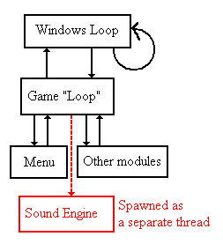

Control Loop
The control for Fallback begins in the Windows module, where the game window is created. During the windows messaging loop, the game loop is called. Within the game loop, game logic is executed, and then control is passed back to the windows loop.
The game loop will call various modules, passing control to them as necessary.

The sound module will spawn a separate thread, utilizing DirectSound capabilities.

Modules

Game Module

Overview
The game module is the core of the Fallback engine. It is the hub that calls all other modules, and determines what to do with what it gets back.
In simplest terms, it retrieves the input, evaluates that based on a series of tests, and then returns graphics and sound based upon the results.
It consists of a central function that retrieves the input (by Input engine or Networking), checks for interaction with units or the menu, executes the unit AI, executes scripts, and then calls upon the sound and graphics engines to perform their tasks.
Within the scope of the game module, there also exists a scripting module, which reads in scripts and parses them. See Appendix C for information on the script file format.

Classes/Structures
The game module will have massive lists of all objects, with reference IDs.
It will also have a list of player structures, each of which contains a list of units, which in turn hold a list of inventory. Neutral units will be held under a special player structure in the list.

Public Interface
Functions will be in place for graphics to ask what to draw, and for AI to ask what units are in range.

Private Interface
The private interface for the game module is massive. All functions that are going to be required to call upon the various modules, and to execute game logic will exist in this module.

Graphics Module

Overview
Graphics will be displayed utilizing the DirectX 8.1 Direct3D libraries. Nearly all access (excluding some model access by the game) will be accomplished via a public Graphics Manager interface. The Graphics Manager will allow restricted access to the creation, loading, and changing of layers (holding model instances, sprite instances, and text objects), and the addition, removal, and enabling of light objects.

Classes/Structures
The primary class/structure of the Graphics Module is the CGraphicsManager object, which holds all graphics objects and allows access to them. It includes the LayerList object, and all “Resource” objects.
The IGraphicsManager virtual interface is all that other modules get access to. It exposes access to the graphics objects.

Models and Sprites have “Instance” and “Resource” objects. The resource objects are the actual models and images, as will be displayed. The instance objects are mere references of the resource objects, including position, scaling, and so on.
Text objects only have 1 type, and they reference a Font object held within the Graphics Manager.
Layers contain a list of sprite instances, model instances, and text objects.
Light objects are contained within the graphics manager, and exist separate of the layers. The reason for this approach was so that we could separate the units and map onto separate layers, whilst still allowing the lights to affect both.

Public Interface
The IGraphicsManager object is the public interface to the Graphics Module.
It contains a multitude of access functions, all along the lines of:
int ObjectTypeSet/GetAttribute( … )

It also includes the DrawLayers function, various clean-up functions, and resource/instance add/remove functionality.

Private Interface
The private interface is the actual implementation of the public interface, with the addition of some list functionality, which the rest of the modules do not require access to.

Sound Module

Overview
Fallback’s sound module will handle both sound effects and musical tracks in WAV and MP3 format. The module will be multi-threaded, and will utilize DirectX APIs to play back the sounds in a 3D positional fashion, based upon where the player is currently viewing. To do this, it will acquire the position of various objects from the game.

Classes/Structures
The sound module will have structures holding DirectSound channels, buffers, and so on. There will also be structures for containing sound effects, and music tracks, as well as structures holding lists of these.

Public Interface
int PlaySound( sound_id, position ) // play specified sound
int StartMusic( music_id ) // begin specified musical track
int EndMusic() // end the current musical track
int Pause/ResumeMusic() // pause/resume the current musical track
int SetVolume( volume_level ) // set the volume

Private Interface
The private interface will depend largely upon the implementation of DirectSound. Functions will exist for the sound and music lists (retrieval, adding, removing), as well as initialization functions, and music/sound handling wrapper functions around DirectSound.

AI Module

Overview
The AI module gets information from the Game module, performs logic for each individual unit, and gives the units directions based on the input. Each AI keeps track of its state, which modifies how the input is processed. The AI module’s public interface allows level scripts to give commands to the AI.

AI States
Idle: When the unit has no commands and no known enemies, it is in the idle state. The unit will call the “Look” function periodically.

Under Fire (Passive AI): The unit knows of an enemy, and will take cover from it. If the enemy comes too close, the unit will retreat. If the enemy is too close, the unit will use its melee attack. The AI remains in this state until all known enemies are killed or are not seen for more than two minutes.

Engaged (Aggressive AI): The unit will use the “Fire on Target (enemy)” function. However, the unit will remember its original location and try not to stray too far. The AI remains in the Engaged state until all known enemies are killed, the unit receives another order, or no enemies are seen for more than two minutes.

Attacking (Attack Command): When commanded to attack, the unit will use the “Fire on Target” functions. When the target is killed, the unit will go back to the idle state (though it may go immediately back to Engaged if it sees another enemy).

Classes/Structures
Each AI will keep track of the following variables:

AI State: This will be an enumeration of the AI’s current state.

List of Known Enemies: A list of base Unit objects, shared with nearby friendly units. These objects are not the actual enemy data structures, but copies that the unit fills with data it perceives. Primarily used for tracking the location of enemies.

Passive/Aggressive flag: The player can set unit AI to either fire on any enemy it sees, or conserve ammunition and try to hide from enemies.

Target Location(s): A list of locations that the AI is currently trying to move toward. Multiple locations are stored so that the unit doesn’t need to re-figure a path constantly and can instead travel through a list of waypoints, updating the path periodically.
Anchor Location: When the unit goes to Engaged state or is ordered to Hold Position, their current location is stored in this variable. The unit will be constrained and will attempt to stay within a short distance of their anchor location.

Public Interface
Set AI State: Using this public function, the AI’s state can be modified by an external force, such as scripted events during a level.

Set AI Target: When an allied unit spots an enemy, it sets all nearby AIs targets to the new enemy. Level scripts will also use this function.

Private Interface
Seek Cover: The unit casts rays from varying locations around its position toward the known enemy locations, at both standing and prone heights. If the ray intercepts a map object or vehicle before reaching the enemy location, the unit considers the origin of the ray to be cover. The unit will then choose from available covers based on proximity.

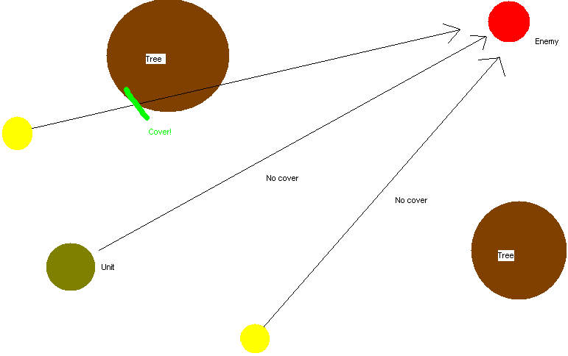

Fire on Target (enemy): The unit casts rays toward the enemy’s location from nearby locations and determines if it is possible to fire on the enemy at this point. If the enemy is out of range or concealed, the unit will approach the enemy using the Move AI. When firing is possible, the unit will try to find cover nearby that allows the unit to continue firing on the enemy. If the unit loses sight of the enemy, it will continue firing on the enemy’s last known location. If the unit doesn’t see the enemy for more than 30 seconds, it will “forget” about the enemy and go to an idle state.

Fire on Target (location): This function functions much like firing on an enemy target. With this function, however, the unit will continue firing on the target location until ordered to do otherwise, or the unit runs out of ammunition.

Move: Using the A* algorithm, the unit will find the shortest path to the target location. By weighting points near known enemies, the unit will attempt to circumvent enemy locations as much as possible.

Look: Every few frames, the unit will cast rays toward all enemies within a certain distance (modified by the unit’s perception). If the unit has a clear line of sight to the enemy, it calls the “Enemy Sighted” function.

Enemy Sighted: When a unit spots an enemy, it changes state to Engaged. At this time, units will “tell” all other friendly units within 50 meters the enemy’s location, and set their states to Engaged. Human units spotting enemies will also trigger an effect on the player’s HUD to notify them of the enemy.

Networking Module
See the Multiplayer/Networking section.

Input Module

Overview
The Input module for Fallback uses the Windows module to receive input from the mouse and keyboard. Each frame, the input module determines the state of the mouse and keyboard and relays this information to the menu and game.

Classes/Structures
class MouseState
{
public:
//Location
int x;
int y;

bool bLButton; //0 = up
bool bRButton; //1 = down

bool bLClick;
bool bRClick;

int focus;
};

Public Interface
int GetMouseLocation(int* x, int* y);
int GetMouseButtons();
int GetKeyCode(int* VKeyCode);
int GetKeyChar(char* KeyPressed);
int SetMouseFocus(int focus);
int GetMouseFocus(int* focus);
int ClearKeyboardInput();
int ClearMouseClicks();

Private Interface

File I/O Module

Overview
The file input/output module will be a collection of load and save routines for various files. For loading, the load function opens a map file, and then reads in all the pertinent information. The text file is parsed using special characters. The special characters and their correlations are listed below:

&d == Dimensions of the level
&i == Num items:
foreach item{itemId, ammo, health, quantity, locationX, locationY};
&t == Tiles. First number is the total number of tiles. The next is the index in the tile set.
&c == inital camera position: x, y

&p == Num Peoples;
Foreach player:
int UnitType;
int OwnerID;
int Model;
char[20] name;
int ItemCounter;
foreach item{ itemId, ammo, health, quantity, locationX, locationY };

int SkillStrength;
int SkillPerception;
int SkillFirearms;
int SkillDemolitions;
int SkillDoctor;
int player Location

&b == Num Buildings;
Foreach building:
int UnitType;
int OwnerID;
int BuildingType;
int Model;
int Building Location;

&v == Num Vehicles;
Foreach Vehicle:
int UnitType;
int OwnerID;
int VehicleType;
int Model
int Vehicle Location

For saving, the module opens a file with the name of the current profile, it then saves the progress of the player to the file for later review.

Classes/Structures
struct sPoint
{
int x,y;
};

struct FileItem
{
int FileItemNumber;
int Ammo;
int Health;
int Quantity;
sPoint Location;
};

class FileUnit
{
public:
void operator =(FileUnit first);
int Model;
int UnitType;
int VehicleType;
int BuildingType;
int OwnerID;
int FileItemCounter;
int SkillStrength;
int SkillPerception;
int SkillFirearms;
int SkillDemolitions;
int SkillDoctor;
char name[20];
sPoint Loc;
FileItem* FileItems;

};

class Level
{
public:
sPoint Dimensions;
sPoint CameraPos;
int* Terrain;
int FileItemCounter;
FileItem* FileItems;
list<FileUnit> Units;
};

Public Interface
int LoadMap(char* fileName, Level* level);
int LoadGame(char* playerName, int level);
int SaveGame(char* playerName, int level);
int FreeTerrain(Level* level);
int FreeItems(Level* level);

Time Module

Overview
The time module is by far the smallest module. It will keep track of a time offset, and be used in the evaluation of game scripts, as well as to let players know how much time they have spent on various tasks.

Classes/Structures
structure time
{
time begin; // when the timer was started
time offset; // the current time of the timer
}

Public Interface
int StartTime( time structure )
int GetTime( time structure )

Private Interface
int UpdateTime( time structure )

Math/Physics Module

Overview
The Math/Physics Module will contain all mathematical collision functions, as well as definitions of the in-game mathematical units (such as matrices, vectors, et al)

Classes/Structures
struct SVector3D
{
float x, y, z;
...
// operators will go here
}

struct SPoint3D
{
float x, y, z;
...
// operators will go here
}

struct SMatrix3D
{
float m[4][4];
...
// matrix math operators will go here
}

struct SRect
{
float top, left, bottom, right;
}

struct SBox3D
{
SPoint3D corner;
SVector3D extent; // diagonal vector
}

Public Interface
Mathematical functions. There are quite a few that we will use, including the addition of a point and a vector, collision between vector and box, collision between a circle and a rectangle.

Windows Module

Overview
The Windows Module will cover all the window functions such as creating the window, calling the Game Module and closing the window. We are going to utilize the standard Windows APIs.

Public Interface
WinMain() // Main function, containing the message loop
WinProc() // Windows procedure, handling messages
WinInit() // Initialization function for window creation

Menu Module

Overview
Graphically, the menus will be implemented utilizing the 2D capabilities of the in-game graphics engine.
There will be several different menus. The first one comes up when the game is started, and allows you to load a saved game, enter multiplayer, etc. The second menu will be the in-game menu, which will allow you to save or load games. Lastly, there will be the inventory menu for a unit, which will be handled within the game. This menu will allow you to manipulate the unit’s possessions and view the unit’s attributes. For the options and multiplayer menus, the menus will call the appropriate functions or change the appropriate data, as specified by the network and sound/graphics modules, respectively.
Each button on the opening level of the menu will have a variable named after it, set to 0 at initialization. Once a button is clicked on, it’s variable will be set to one, and the menu will move to that level. From there, the menus will directly call the necessary functions when the next buttons are clicked upon, as the second level of menus will handle the exact bits of the game, be that loading/saving data, changing sound or graphics, or multiplayer.
For the in-game menus, the game menu will operate the same as this one, while the inventory and map menus will simply call the necessary functions when opened or the hotkey is pressed.
The Map Menu will simply be a screen displaying the four necessary bits of information, the terrain view, the mission description, mission objectives, and the unit/structure list.
The inventory will call up a list of the units, each of which will contain a list of the items the individual unit is carrying. From there, the function will handle the manipulation, but the general idea will be a drag-and-drop interface. If an item is dropped off the inventory of the unit, it will be removed from the list. If it is given to another soldier, it will move to that unit’s item linked list.
The building and vehicle menus will call up a list of the positions within the building or vehicle that can be filled. The player will click on where he wants the unit(s) to be stationed, and they will placed in that area, in the structure’s linked list of passengers. If only the building or vehicle is accessed, then a list of units will be provided, and clicking on a unit will find that unit in the structure’s linked list, and the unit will be removed, and placed back on the world map.
As well as placing and removing units, building will also have other abilities that the player will access. Opposing Command Centers will have the Capture option, allowing units to enter and attempt to take the Command Center for themselves. That will be handled by using the individual units skills to determine time and effectiveness. Allied Command Centers, like allied Vehicles, will possess inventories that units can interact with, acquiring new weaponry and items, or storing the same. That will be handled the same as unit inventory, as both inventories will be called, and the items possessed by both will be placed upon the screen, allowing the player to interact with them in a drag-and-drop style. Items moved will be removed from one inventory’s storage, and placed in the others.

Classes/Structures
structure MenuData
{
int Area; // starting menu or in game menu
int Depth; // every menu will have levels, 0 being the
// starting level. Entering another menu, for
// example, choosing to load a game from the
// start menu, will go up one level, changing
// the level from 0 to 1.

structure StartMenuData
{
int SinglePlayer, MultiPlayer, Options, Credits;
// these will be initialized to zero, should the
// player click on the appropriate button, the
// correct variable shall be set to one, and the next
// level of the menu will open.
}
structure InGameMenuData
{
int Load, Options;
// these will be initialized to zero, should the
// player click on the appropriate button, the
// correct variable shall be set to one, and the next
// level of the menu will open.
}
}

Public Interface
int MenuGo() // the main menu function, handling movement
// menu logic, including movement and actions

Private Interface
int CheckInput( ... ) // calls the input module and checks for
// button presses
There will also be specific functions tied to various buttons.

Data Flow
The various modules will call upon the File I/O module to load data. The information will then be parsed and passed back to them. File output is only utilized for save games.
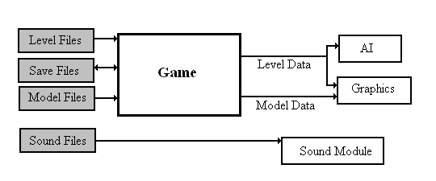

Game Physics and Statistics
Unit statistics are kept track of in the Game Module.
Physics are handled within the Math Module
For information on AI, please refer to the AI Module.

Optimization
For Fallback, we do not plan on any optimization at the moment, as we feel that our game will not be overly processor intensive.

Multiplayer/Networking

Peer-To-Peer Structure
Most RTS games use the Peer-To-Peer networking structure, hence we will as well. In Peer-To-Peer, there will be a host that will essentially just route information, but will in no way be a determiner of game events. If a peer wants to send a message to all other peers, he will send a message to the host and the host will route the information to everybody else. The DirectPlay APIs, which we will be utilizing for the networking module, will take care of all the routing by themselves.
In order to ensure consistency of game data among peers, every time a peer sends a message to another peer, he will wait for an acknowledgement message. If no acknowledgement is received after a certain amount of time, the network will pause the game until the lagging peers are re-synced with the other peers. If the lagging peers are unable to synchronize then they will be ejected from the game.
Also under the Peer-To-Peer model, each peer is responsible for determining what happens to their units – when they take damage, die, get run over by a car, their AI states, etc.

Updating Data
Almost all data will be updated as it is changed. When a unit changes it’s stats, a notification packet will be sent to all peers of the change. For data that is frequently changing, such as position when a unit is on the move, that information will be sent out at a ten times per second rate.

AI Opponents
As in most RTS Peer-To-Peer games, AI opponents will be handled by the host player, and the updates of their data will be sent by the host player. What makes the AI players move will be determined by the AI module.

Data Structures
typedef struct _DELTA_POS{
POINT ptPos; //the positions of the unit
DWORD dwID; //the ID of the unit
} DPOS;

This structure contains a unit’s change in position since the last time the position was updated to the network.

typedef struct _NDATA{
DPOS* dpPositions; //list of the positions of the units that //have changed (contains IDs)
} NDATA;

This structure contains all the delta position structures since the last update.

typedef struct _ACK{
DWORD dwTime; //the time the message was sent
DWORD dwID; //the ID of the message
} ACK;

This is the acknowledgement structure that will be used for the acknowledgement list. Every time a message is sent, an ACK will be added to the ACK list, containing the time and ID of the message that was sent. When the acknowledgement message is received the ACK will be removed from the ACK list.

typedef struct _DPN_PLAYER_INFO{
DWORD dwSize;
DWORD dwInfoFlags;
PWSTR pwszName;
PVOID pvData;
DWORD dwDataSize;
DWORD dwPlayerFlags;
} DPN_PLAYER_INFO, *PDPN_PLAYER_INFO;

This is a DirectPlay structure that contains the DirectPlay data for each player. They will be held in their own list of players on each player’s machine.

Public Functions
The networking module will make several functions available to the other game modules. They include:

bool InitializeNetworking(); //initializes DirectPlay, gets networking
//module set up
bool UnInitializeNetworking(); //uninitializes networking module,
//frees DirectPlay
void HostGame(); //sends player to pregame screen,
//sets up DP Host
void* ScanForGames(); //scans for available games and
//returns their data
void JoinGame(); //joins with a host
void SendPacket(packet*, type); //for sending event packets
//(chat, death, etc)

Private Functions
SendPacket(); //sends packet of data
CheckForAcks(); //scans list for laggers, brings up
//lag menu when necessary
SyncLaggers(); //syncs game with laggers until they stop
//lagging, or kicks them out after a certain
//amount of time passes
SendUpdate(); //sends an update of the player’s stats,
//waits for acknowledgements

DirectPlay Message Handler
During initialization, DirectPlay will create a message handler function that runs on it’s own thread and is used for receiving messages from the network. It has the following parameters:

HRESULT MessageHandler(PVOID pvUserContext, DWORD dwMessageType,
PVOID pMessage);
The member dwMessageType defines the type of message that is sent. We know, for sure, that we will be using the following DirectPlay messages, and possibly more.

DPN_MSGID_RECEIVE //This message is received whenever game data is transferred. It will be the message received most often.
DPN_MSGID_CONNECT_COMPLETE //This message is received when the player is attempting to connect with other players, and the connection has gone through.
DPN_MSGID_CREATE_PLAYER //This message is received by already connected players when another player joins. The messages contains data about the newly connected player.
DPN_MSGID_HOST_MIGRATE //This message is received whenever the host player leaves the game (by defeat, on his own, or by lagging too much).
DPN_MSGID_DESTROY_PLAYER //This message is received when a player dies and leaves the game.

External Libraries
DirectPlay 8.1 Peer-To-Peer APIs
Windows Synchronization Functions (EnterCriticalSection and LeaveCriticalSection)

Packets
The networking module will have a series of different types of packets for sending data across the network. They include:

class _P_GENERAL {
DWORD dwID; //The Packet’s ID tag (or time stamp)
DWORD dwPlayerID; //The ID of the player that sent it
DWORD dwType; //The type of packet
DWORD dwSize; //The size of packet (for DirectPlay to use)
} P_GENERAL;

P_GENERAL will be the base packet from which all other packets will inherit.

class _P_CHAT : public _P_GENERAL {
char* pchText; //the text being sent
} P_CHAT;

P_CHAT is used for sending chat messages

class _P_UPDATE : public _P_GENERAL {
NDATA dtData;
} P_UPDATE;

P_UPDATE is used for sending the player’s game data to other players. However, it will only send data that is updated most frequently (i.e. unit’s position).

class _P_ACKNOWLEDGE : public _P_GENERAL {
DWORD dwAckID; //The ID of the packet that is being ack’ed
} P_ACKNOWLEDGE;

P_ACKNOWLEDGE is sent after a packet is received.

class _P_ENDGAME : public _P_GENERAL {
(No Contents)
} P_ENDGAME;

P_ENDGAME is sent when the game is over, and it is time to go to the end game screen.

class _P_STATCHANGE : public _P_GENERAL {
DWORD dwID; //The ID of the unit
DATA dtStats; //The updated stats of the unit
} P_STATCHANGE;

P_STATCHANGE is used to notify other players when a unit’s stats have been altered via upgrade, taking damage, getting into a vehicle, or other means.

class _P_FIRE : public _P_GENERAL {
DWORD dwID; //The ID of the unit that is shooting
POINT ptTar; //The position/unit that the unit is firing at
} P_FIRE;

P_FIRE is used to notify other players when a unit is firing at another unit.

class _P_DESTROYED : public _P_GENERAL {
DWORD dwID; //The ID of the unit that was destroyed
} P_DESTROYED;

P_DESTROYED is sent out to all other players when you determine that one of your units has been destroyed.

UI

In-game mouse interface
- Left click
  - On friendly unit, vehicle, or building: select object
  - On terrain: De-select.
  - On enemy unit: Display information
- Right click
  - With nothing selected:
    - On building: Unload building
    - On vehicle: Unload vehicle
  - With unit selected
    - On ground: Move
    - On enemy: Attack
    - On vehicle: Enter Vehicle (if applicable)
    - On building: Enter building (if applicable)
  - With Vehicle Selected
    - On selected vehicle: Unload Vehicle
    - On ground: Move (if vehicle has driver)
    - On enemy: Attack (if vehicle has gunner)
  - With Building Selected
    - On enemy: Attack (if building is manned)
    - On selected building: Unload Building

Keyboard interface
- Keyboard Shortcuts
  - A: Attack
  - S: Stop
  - R: Reload
  - X: Hold Position
  - M: Move
  - D: Prone/Stand
  - T: Aggressive/Passive AI
  - B: (Engineer) Salvage
  - H: (Medic) Heal

HUD
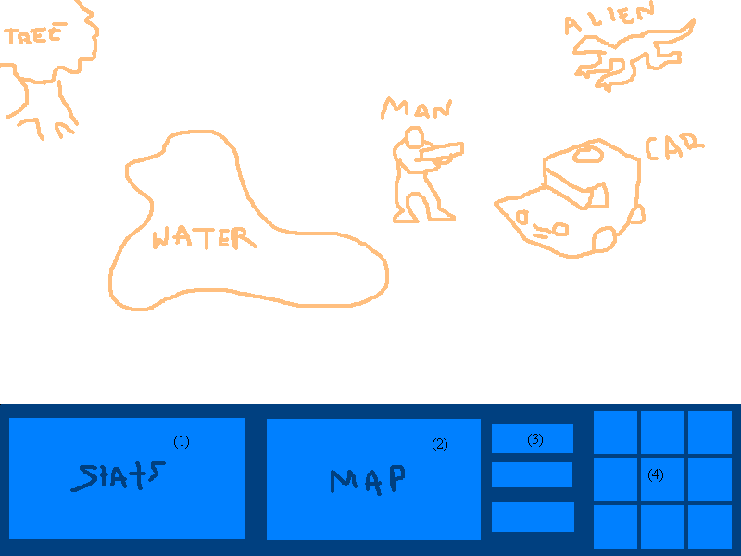
- Selected-Unit details (non-interactive)
  - Unit portrait
  - Health Bar and Summarized stats
  - Relevant Inventory
- Mini Map (interactive)
  - Terrain
  - Visible Units
  - Selected Units highlight
- Menu access (interactive)
  - Inventory
  - Map
  - Game Menu
- Unit Commands (interactive)
  - Move
  - Stop
  - Attack
  - Reload
  - Hold Position
  - Stand/Prone toggle
  - Passive/Aggressive AI toggle
  - (Medic) Heal
  - (Tech) Salvage

Installer
We will be using a freeware software application called Inno Setup for the creation of our installation program. (http://www.jrsoftware.org/isinfo.php)
Our program will perform a full installation from CD or compressed file. No other installation type is planned.

Copy protection / Anti-hacking devices
At this juncture, we do not plan on implementing any copy protection schema, nor anti-hacking functionality.

Tools
For modeling and animation, we plan on using 3DS Max and an export tool to save in Direct3D X file format.
Maps and other in-game data will be stored in plain text format, and will be edited appropriately using Notepad or some other low-level text-editing program.
We will be utilizing Microsoft Visual SourceSafe to automate our version control and code sharing.

Appendix A: Naming/Coding Conventions

Files
Files will be named based on their purpose. To remove confusion, the separate modules/projects will be in their own folders.
For example, the input module folder could look like this:
input module\
input_pub.h // public interface header
input_priv.h // private interface header
input.cpp // input module implementation

Another example, a more complex module’s folder, such as that of the graphics module, could look like something along these lines:
graphics module\
graphics_pub.h // public interface header
graphics_priv.h // private interface header
graphics.cpp // main graphics module implementation
models.h // internal 3d models specific header
sprites.h // internal 2d sprites specific header
layers.cpp // layers implementation
...

Functions
Functions will all return an integer error/success-code, and all other input and output will be done within the parameters.

Variables
Variables will be prefixed with some set of characters to signify their type.
These character prefixes will be largely based on the near-de-facto standard Hungarian notation, but with minor alterations.
Parameters for functions will be prefixed or suffixed with some additional character to signify their type as an input or output variable.

Commenting
All functions will be commented at declaration as to their purpose and the purpose of their parameters.
Files will have a comment header, declaring the module they belong to, and any other pertinent information.

Appendix B: Graphics/Sound Formats

Graphics Formats

2D Graphics
File Format: BMP
Attributes: 32-bit

3D Graphics
File Format: 3DS MAX file, converted to Direct3D X file

Sound Formats

Sound Effects
File Format: WAV
Attributes: 44.100 kHz, 16-bit, Stereo

Music
File Format: MP3
Attributes: 44.100 kHz, 128 kbps, Stereo

Appendix C: Script File Format
Scripts for Fallback will be written in formatted near-regular English.
The full extent of the scripting engine has yet to be decided upon, and so the full format is still nebulous.

Examples:
Level
{
showObjective(1)
if Objective(1) then showObjective(2)
if Objective(3) then winLevel
}
Objective(1, required)
{
succeed if building(1) is captured by player
}
Objective(2, not required)
{
succeed if building(2) is destroyed by player
fail if building(2) is captured by enemy
}
Enemy_AI({2,3,7})
{
if player within( xx, yy, target ) setAI( moveto, x, y )
}

TDD Version 2 Changes

- Fixed header, added Class / Date information.
- File I/O section updated; format information added as well as Class information.
- Menu section updated.
- Networking section updated.
- Input section updated.
- UI section updated.

